Lesson Plan: Romanticism Symphony Fantastique Aural Analysis
Unit Title: |  | Romantic Music Prelim |  | Stage: 6 |  |  | Year: 11
Lesson Title: |  | Berlioz Symphony Fantastique |  | Class: 11 Mus |  |  | Duration: 50
Content Strands: |  | Listening
Rationale: |  |  | Resources: |  | Prior Knowledge:
- This lesson will build on students’ prior knowledge of the concepts of music to discuss the effects of unity and contrast as a result of the manipulation of the concepts.  - Students develop skills in order to recognise, analyse and comment on all concepts of music and unity, contrast and style.  - Students will develop their aural listening skills through melodic dictation. |  |  | - Commbox  - Computer/projector/audio  - Audio examples Fantastique  - Manuscript paper  - Hector Berlioz’s Symphonie Fantastique opus 14. – prep computer/projector before lesson |  | - Students have been learning about the concepts of music through identifying and discriminating ways in which musical concepts have been used and manipulated, within the context of Theatre Music.
Outcomes: |  |  | Indicators: |  | Assessment:
P2 demonstrates an understanding of the concepts of music, by interpreting, analysing, discussing, creating and notating a variety of musical symbols characteristically used in the mandatory and additional topics  P5 analyses and discusses compositional processes with stylistic, historical, cultural and musical considerations  P6 discusses and evaluates music making constructive suggestions about performances and compositions  P7 observes and discusses in detail the concepts of music in works representative of the mandatory and additional topics |  |  | - Students make notes in their books summarising the elements of pitch, expressive techniques, texture, duration,  - Students recognise sections of unity and contrast; similarities and differences in the listening excerpt.  - Students refer to appropriate and related musical concepts in their responses to support their observations.  - Students demonstrate evidence of focussed listening, and apply their understanding of musical concepts.  - Students actively participate in discussions and make insightful contributions.
Timing | Content |  |  |  | Comments
 | Introduction
5 mins  10 mins | Students will listen to two excerpts from Un Ball, mov. V, Songe d’une Nuit du Sabbat from Symphonie Fantastique by Hector Berlioz. Refer to the score in relation to the listening.  The excerpt will be played 4 times to answer questions 1 & 2.  Score Attachment  You have 60 seconds to look at the score  Times: First Playing - 10 second pause  Second Playing – 1 minute pause  Third Playing - 1 minute pause  Fourth Playing – 2-minute pause  The following questions need to be answered:  Name the chord the woodwind instruments are playing in bar 3.  Name the chord the woodwind instruments are playing in bar 3.  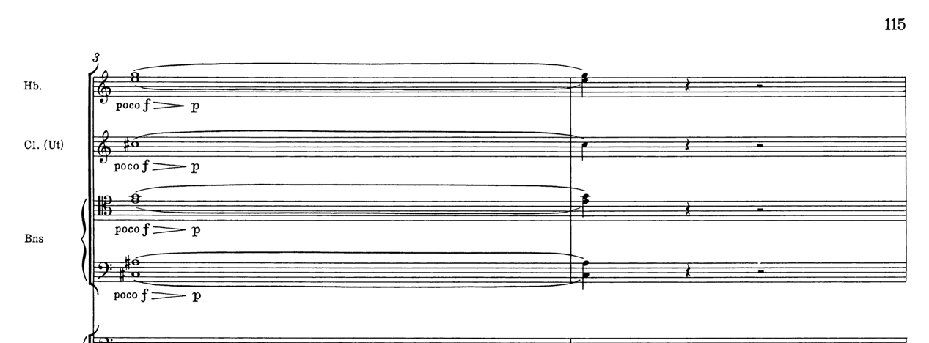  Describe the meaning of the following.  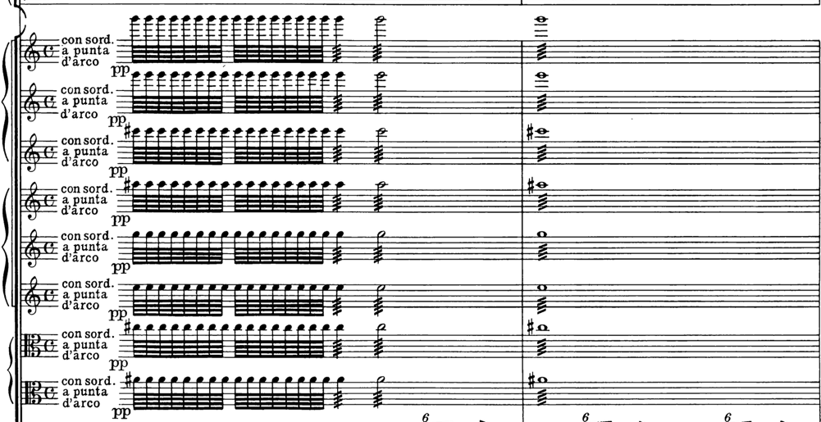  v  Describe the meaning of two different figures.  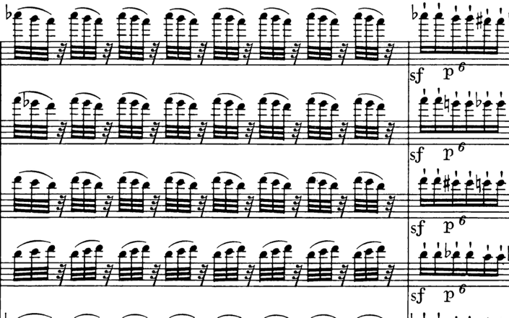 |  |  |  | Classroom organisation and environment:  Room: M1 (Layout - tables and chairs in rows, audio/computer/projector)  Students enter room and sit at tables.  Administration:  Roll call  Teaching strategies:  Activate prior knowledge  Assess students’ individual differences and level of understanding  Lesson overview  Resources required:  Laptop/ and Audio excerpts from Symphonie Fantastique  Manuscript paper
10 mins  10 mins | The excerpt is based on bars 1-8.  You have one minute to look at the score.  Question 1: (8 Marks)  - Describe how tension is created through pitch, and tone colour in bars 1-8.  a)  Question 1 (continued)  b) With reference to duration, and texture, discuss how interest achieved in this excerpt.  c) Describe the use of expressive techniques in this excerpt and make specific reference to the score.  Question 2  Excerpt 2 will be played 4 times.  You have ONE minute to look at the score.  - Explain how through texture, and pitch, the mood is developed in the excerpt in bars 59-76.  Students Share their findings with the class |  |  |  | Resources required:  - Hector Berlioz’s Symphonie Fantastique opus 14. – prep computer/projector before lesson  Assessment strategies:  - Teacher questioning to check for depth of student understanding.
10 mins | Conclusion  - Recap with students what was analysed in the piece of music.  - Answer any final questions.  - Wrap up the lesson
Teaching strategies:
Summary of content
Assessment strategies:
Teacher questioning to check for student understanding.
Evaluation:
Have students met expected outcomes of lesson?

What worked well within the lesson?

What did not work so well?

How could you improve this lesson?

